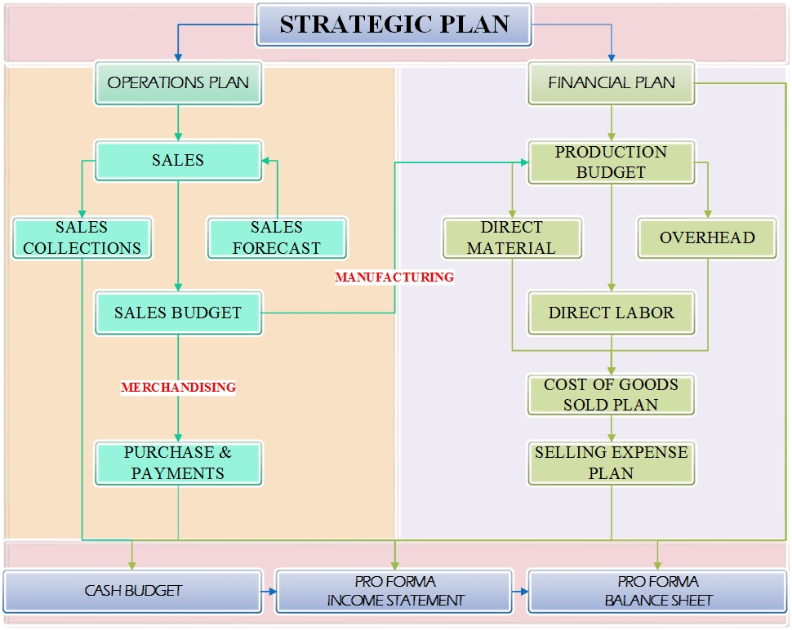
ANNUAL PLAN BUDGETTING
The annual plan anticipates the coming year's activities that will contribute to the accomplishment of the long-term and short-term goals outlined in the company's strategic plan. This plan expresses management's operating and financial plans for a specified period (usually a year) and it reflects the impact of both operating and financing decisions. The operating decisions deal with the use of scarce resources and the financing decisions deal with how to obtain the funds to acquire those resources.

- OPERATIONS PLAN

Operations Plans are plans that identify needed resources and the way that these resources will be acquired for all day-to-day activities such as sales and services, production, purchasing, marketing, and research and development. In the operating budget, the emphasis is on obtaining and using current resources.

• SALES FORECAST
The sales forecast has to take into account what we expect to sell at what sales price.
- In order to develop budgets, the system will first make a forecast of what drives much of the financial activity; namely sales. In order to estimate sales, the system will look at the past sales histories and various factors that influence sales.
- A sales forecast estimates future sales of the system's products and is the starting point in preparing sales budgets for the period.
- An accurate sales forecast enhances the usefulness of the budget as a planning and control tool. Sales forecasting by its nature is subjective. To reduce subjectivity in forecasts, the system could generate several independent sales forecasts as a standard procedure.
Scenario 1:
The company has its market research unit, the manager of its business unit and the sales department of its budget unit prepare a sales forecast. As a result, the volume of sales in the sales budget would be the one that all parties agree is the most likely prediction.

Some factors that should be considered in sales forecasting:
• Current sales levels and sales trends of the past few years.
• General economic and industry conditions.
• Competitors' actions and operating plans.
• Pricing policies.
• Credit policies.
• Advertising and promotional activities.

Some factors about the sales forecast usage:
- Determine that demand is highly elastic for mature products.
- Determine that growth will come only from new product intro and current products cost savings.
- To determine that a tight monetary policy on Fed's part must cause to tighten credit standards.
- A competitor that is a low-cost producer is moving into markets when the budgeting company is.

All of these factors must be taken into account when forming expectations about product sales for the coming budget cycle. After having collected and analyzed all of the relevant information, the estimate sales volumes for the planning period can be estimated. It is very important to obtain a good estimate since it will be used to estimate other several budgets in the system.
• Sales Collections:

Sales Plan:
The sales budget projects the volume of sales for the coming period in both units and dollars and it is used as the basis for the preparation of all other budgets.
- Preparation of the sales budget for a period starts with the system forecasted sales level, production capacity, and long-term and short-term objectives.

- A sales budget is the cornerstone of budget preparation because the system can complete the plan for other activities only after it identifies the expected sales level.

- The system cannot complete the production schedule without knowing the number of units it must produce, and the number of units to be produced can be ascertained only after the system knows the number of units budgeted to be sold for the period.

- Once the number of units to be sold and produced has been determined, the units of materials to be purchased, the number of employees needed for the operation, and the required factory overheads can be determined.

- Expected selling and administrative expenses also are determined by the desired sales level.

The role of sales budget in the development of the annual profit plan:
- Preparation of a sales budget is the first step in the comprehensive budget process.
- Once sales have been determined, related budgets can be prepared, such as the production budget, expense budgets, and pro forma financial statements.

Components of Sales Planning
- Production Budget
  - Direct materials budget
  - Direct labor budget
  - Manufacturing overhead budget
  - Ending finished goods inventory budget
  - Cost of goods sold budget
  - Pro Forma Income Statement

- Merchandising (Nonmanufacturing):
(Selling, General & Administration) budget -> (The value chain activities)
  - Research and development budget
  - Design budget
  - Marketing budget
  - Distribution budget
  - Customer service budget
  - Administrative budget
  - Pro Forma Income Statement

• PRODUCTION BUDGET
A production budget is a plan for acquiring and combining the resources needed to carry out the manufacturing operations that allow the system to satisfy the sales goals and have the desired amount of inventory at the end of the budget period.

The total number of units to be produced depends on:
- The budgeted sales
- The desired amount of finished goods ending inventory, and
- The units of finished goods beginning inventory.

Future Period Budget:
- The system does not know what the actual sales and production volumes will be.
- All revenues and costs in the master budget are based on forecasted volumes.
- Once the system knows the expected sales, production is estimated.
- The production budget is based on assumptions appearing in the sales budget.

The master budget is a static plan because it is developed for one specific sales level:
- Variance reports are prepared by comparing actual results to budgeted results.
- Causes for variances are reported as well.
Note: Most common cause is that the actual sales volume was different from planned volume.

The system must balance opposite goals to selecting a desired ending inventory for a period:
- If the system has insufficient inventory, then sales are affected. And
- If the system has an excessive amount of inventory, then it becomes costly.
- The system must determine how quickly it can increase production if demand warrants and
- Set its desired production and inventory levels accordingly.

The system needs to have the ability to coordinate sales needs and production activities to have a plan that allows the company to identify mismatches between capacity and output. As a result, these are some factors that should be considered when preparing a production budget:
- Managers review the budget to ascertain that the company can:
  - Attain the budgeted level of production with the facilities available
  - Keeping in mind all activities scheduled for that period.
- If the production level exceeds the maximum capacity available:
  - Management can either revise the budgeted sales level or
  - Find alternatives to satisfy the demand.
- If the available capacity exceeds the budgeted production level:
  - Management might want to find alternative uses for the idle capacity or
  - Schedule other activities such as
    - Preventive maintenance and
    - Trial runs of new production processes.

The production plan budgets are interrelated since a change in one may require a change in another. This is the relationship between the direct materials, labor and other production budgets:
- As production changes, the amount of labor the material changes.
- As the amount of labor changes, there may be changes in indirect materials and labor. These are used in manufacturing but their costs are not directly traceable to any particular product.
- As these items change, there may also be a change required in the overhead budget.
- Because of how individual budgets are connected, a change in one is very likely to affect another.

Production Planning Components:
- Direct materials budget
- Direct labor budget
- Manufacturing overhead budget
- Ending finished goods inventory budget
- Cost of goods sold budget

From calculating the production budget, in units, to Pro Forma:
- The production budget determines the units to be produced by adding the desired ending inventory to the units estimated to be sold and then subtracting the beginning inventory.
- The budgets for direct materials, labor and factory overhead for the coming period are based on the required production from the production schedule.
- The cost of goods sold budget may be prepared upon completion of the above budgets.
- Once the level of activity has been determined for sales and production, the selling and administrative expenses budget can be prepared.
- Completing these individual budgets allows the preparation of the Pro Forma income statement
- The cash budget shows the estimated flow of cash and the timing of receipts and disbursements based on projected revenues, the production schedule, and the estimated expenses.
- The capital expenditures budget is a plan for the timing of acquisitions of buildings, equipment, and other significant assets.

- FINANCE PLAN
A financial budget focuses on how operations and planned capital outlays affect cash. Financial plan is a set of budgets that identify sources of funds for the budgeted operation and the uses for these funds during a period to carry out the budget activities. In the financial budget, the emphasis is on obtaining the funds needed to purchase operating assets. In other words, financial planning is a continuous process that flows with strategic decision making. The Operating Plan and the Financial Plan will both support the Strategic Plan. The best place to start in preparing a budget is with sales since this is a driving force behind much of our financial activity. However, the system has to take into account numerous factors before finalizing budgets.

The system should allow modifications if something changes. The following impacts planning:
- Life cycle of the business
- Financial conditions of the business
- General economic conditions
- Competitive situation
- Technology trends
- Availability of resources

The system should allow both upper and middle level management work to finalize a budget.
Challenges within financial planning to make planning value-added:
- Clear channels of communication
- Support from upper-level management
- Participation from various personnel
- Predictive characteristics
- Budgeting should not strive for accuracy, but to support the decision making process
Make the organization achieve its strategic goals and objectives

Components of a financial plan
The financial budget is made up of the capital expenditures budget, the cash budget, the budgeted balance sheet, and the budgeted statement of cash flows:
- Capital Budget (completed before operating budget is begun)
- Cash Budget
- Pro Forma Balance Sheet
- Pro Forma Statement of Cash Flows
- The master budget is finalized only after several rounds of discussions between top management and managers responsible for various business functions of the value chain.
Cash Budget
The last schedule prepared before the financial statements is the cash budget. The cash budget is a schedule of estimated cash collections and payments. The various operating budgets and the capital budget are inputs to the cash budgeting process. A cash budget includes all items that affect cash flows and pulls data from almost all parts of the master budget. In preparing a cash budget, the system reviews all budgets to identify all revenues, expenses, and other transactions that affect cash. In fact, the cash budget includes all cash inflows and outflows during the period without regard to the accrual accounting treatment of the transactions.
The cash budget can be thought as a table showing cash flows such as receipts, disbursements and cash balances over a given period:
- It may be prepared monthly or even weekly to facilitate cash planning and control.
- It anticipates cash needs and allows for the provision of resources to meet those needs.

Cash disbursements can be put into four basic categories:
- Payments of Accounts Payable.
  - Payments for goods or services, such as raw materials.
  - Payments will generally be made after purchases, which will depend on sales forecast.
- Capital Expenditures.
  - Includes all other normal costs of doing business that require actual expenditures.
  - These are payments of cash for long-lived assets. • Long-Term Financing.
- Interest/principal on long-term outstanding debt & shareholder’s dividend payments.

Cash budget and financing:
- An adequate amount of cash is crucial for a business to survive and capture opportunities.
- It brings together the anticipated effects of all budgeted activities on cash.
- It delineates the expected cash receipts and disbursements during the budget period.
- Management can ensure having sufficient cash on hand to carry out:
  - Its planned activities
  - Arrange financing in advance to avoid the high costs of emergency borrowing, and
  - Plan investments to earn the highest possible return from any excess cash on hand.
- The cash budget can be critical to ensuring smooth operations and avoiding crises.
- Valuable in seasonal businesses, few months of revenues matching 12 months of costs.
- Prevent temporary shortage of cash, which may drive to a bankruptcy.

Major sections in the cash budget:
1. Cash available
2. Cash disbursements
3. Financing
- The cash budget is a primary tool of short-run financial planning.
- It allows the financial manager to identify short-term financial needs (and opportunities).
- It will tell the manager the required borrowing for the short term.
- It is the way of identifying the cash-flow gap on the cash flow time line.
- The idea of the cash budget is simple: It records estimates of cash receipts and disbursements.

- Cash available
This section details the sources of cash for operations to use. Two sources of cash:
- The cash balance at the beginning of the budget period
- The cash collections during that period.
  - Include cash collected from sales and accounts and notes receivable.
  - Factors that could affect cash sales and cash collection of accounts include:
    - The sales levels
    - Credit policy, and
    - Collection experience.

The company can engage in no routine transactions that generate cash.
Examples are selling operating assets such as:
- Equipment or a building, or
- Non-operating assets such as land purchased for the site of a factory no longer in use
- All proceeds from such sales should be included in the cash available section.

- Cash disbursements
The cash disbursements section lists all payments, including those for:
- Purchases of direct materials and supplies
- Wages and salaries
- Operating expenses
- Interest expenses, and
- Taxes.
The difference between cash available & disbursements is the cash balance before financing.

Credit and purchasing policies have a direct impact on the cash budget.
- Loose credit policies toward customers' credit result in delayed cash receipts.
- Taking advantage of purchase discounts results in accelerated cash outlays.

- Financing
The system must arrange for additional funds if its cash balance is expected to fall below the desired minimum balance set by management. On the other hand, when the company expects to have a significant amount of excess cash, it must determine how to invest the excess. Return, liquidity, and risk must be weighed for alternative investments. Both the additional funding and planned investments are included in the financing section.

The completed cash budget can be used to plan outside financing activities.
- In case of a cash deficit at some point, the firm can plan ahead to borrow funds or sell stock.
- Dividend policy can be planned using the cash budget.
  - For instance, dividend payment dates should correspond to a time when it has excess cash.

PROFORMAS
- Income statement
- Statement Finance Position
- Cash Flow Statement

Based on these pro forma statements, a company can:
- Determine if it is meeting its pre-determined targets
- Estimate the amount of external funding needed to support its projected sales growth; and
- Perform sensitivity analysis to identify the impacts of estimates, operating, am/policy changes.

- Pro forma Income Statement
The pro forma income statement is used to decide whether the budgeted activities will result in an
acceptable level of income. If the initial pro forma income shows a loss or an unacceptable level of income, adjustments can be made to the component parts of the master budget.

Other strategic objectives can be observed from the pro forma income statement, such as:
- Desired rates of return
- Debt ratio
- Interest coverage ratio (times interest earned)
- The adequacy of earnings per share can also be observed from the pro forma income statement

- Pro Forma Statement Finance Position

Pro forma statements represent a company’s projected financial statements and are useful in the company’s planning process because these statements support four major functions:
- Assess whether its anticipated performance is in line with its established targets.
- Anticipate the amount of funding needed to achieve its forecasted sales growth.
- Estimate the changes effects in assumptions of key numbers by performing sensitivity analysis.
  - To help to identify potential conditions that could lead to major problems.
  - To enable an appropriate plan of actions in case the above condition occurs.
  - Provides with the opportunity to analyze the impact of changing its operating plans.
- Determine if company will remain in compliance with covenants on its long-term debt.
  - Long-term debt usually involves maintaining certain ratios in its financial statements.
  - These ratios can be called covenants, which are part of most loan agreements.
  - It is important to maintain compliance with its debt covenants to avoid bankruptcy.

The debt to total assets ratio (also called the debt ratio)
- The total debt ratio measures the percentage of funds provided by creditors.
- Determines long-term debt-payment ability and the degree to which creditors are protected from the company’s insolvency.
- Creditors prefer this ratio to be low as a cushion against losses.

- Pro forma Statement Cash Flows

Creating the pro forma statement of cash flows:
- Company’s dividend policy is first factored in to determine the amount of dividends to be paid
- Amount of projected retained earnings is added to its current balance sheet to create the pro forma balance sheet.
- Information from the capital expenditure and cash budgets are used to help formulate the pro forma balance sheet.
- Once the pro forma income statement and balance sheet are compiled, the information can be used to create the pro forma statement of cash flows.

Earnings Per Share - Complete the Income statement:
- Interest expense is subtracted from EBIT to calculate EBT.
- Tax is subtracted at a given tax rate to calculate net Income before preferred dividends
- Preferred dividends are subtracted to calculate net Income available to shareholders.
- Net Income available to common shareholders divided by the number of shares of common stock gives the Earnings Per Share.
- Common dividends per share multiplied by the number of common shares equals the total dividends paid on common stock.
- The forecasted addition to retained earnings is net Income available to common stockholders minus total common dividends.

Pro forma balance sheet:
- It is prepared with the cash, capital budgets and pro forma income statement.
- It is the beginning-of-the-period balance sheet updated for projected changes in:
  - Cash,
  - Receivables,
  - Payables,
  - Inventory, among others.
- Budgeting process is repeated if balance sheet indicates a contractual agreement violation.

The pro forma statement of cash flows:
- Classifies cash receipts and disbursements depending on whether they are from operating, investing, or financing activities.
- Direct presentation reports major classes of gross cash operating receipts and payments and the difference between them.
- The indirect presentation reconciles net income with net operating cash flow.

Summary of the Strategic Plan or Master Budget

The financial budget is that part of the master budget made up of the capital expenditures budget, the cash budget, the budgeted balance sheet, and the budgeted statement of cash flows. A financial budget focuses on how operations and planned capital outlays affect cash. The master budget is finalized only after several rounds of discussions between top management and managers responsible for various business functions of the value chain.

1. Master Budgets Benefits:
- Relatively easy to prepare and are the most commonly developed budget system.
- Annual budgets focus managers on common and familiar terminology and formats, and
- Ensure a comprehensive attention to resource requirements to sustain budgeted sales volumes.

2. Limitations
- Master budget amounts are confined to one year at a single level of activity.
- Budget amounts may be much different from actual results, even though the relationship between expenses and revenues is consistent.
- An annual static budget divided by 12 may exaggerate variances due to seasonal or volume
- The product of the process is a set of pro forma financial statements.
- Pro forma financial statements may not provide the type of management information most useful to decision-making.

Master (static) budget Includes, known as Actual budget, Static budget and Static Variance
- Contrast this with a flexible budget, a series of budgets prepared for many levels of activity.
- At the end of the period, management can compare actual performance with the appropriate budgeted level in the flexible budget by preparing another budget based on the actual activity.
- The master budget is a static budget, because it is developed for one specific sales level.
- Variance reports are prepared by comparing actual results to budgeted results in the system.
- Variances causes are also reported
  - One of the causes is that actual sales volume was different from planned sales volume.
  - Variances due to volume variations are expected. Therefore, it is more important to focus on variances caused by other factors.

